**ERENHOUSES**

The website is apartment management system. There is an site that has 5 blocks or houses and its name is EREN HOUSES. There are no flat number because it is not an apartment so people that live in the site, has a block number. Also if any host moved, host can not enter the website.

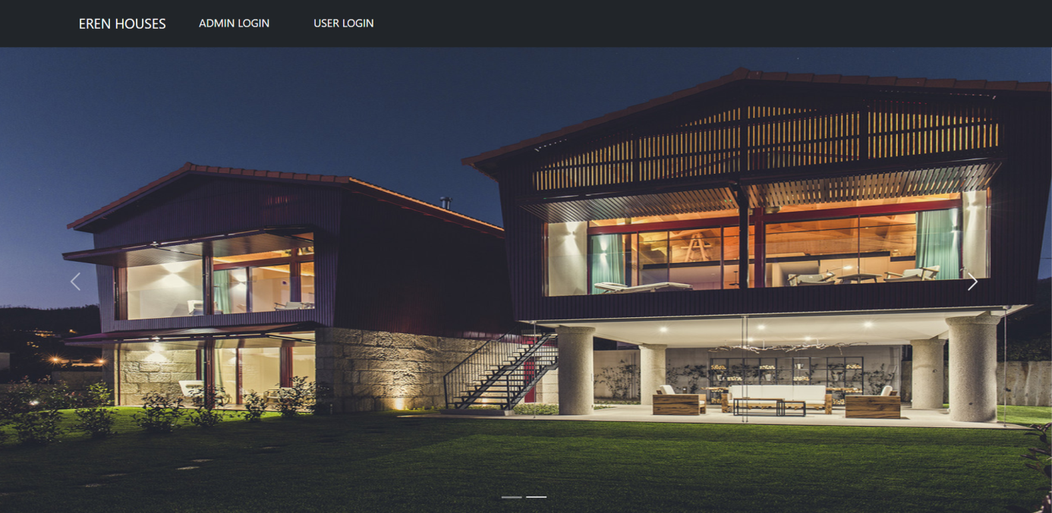

I used bootstrap to make a slide bar and navbar menu. I added 2 picture that belong the site. There are 2 option to enter the website as admin login and user login. If there is a new host who move in the site soon, firstly admin should be admin login into our website and then should fill in the register form with a new host and it is done.

User Login Page :

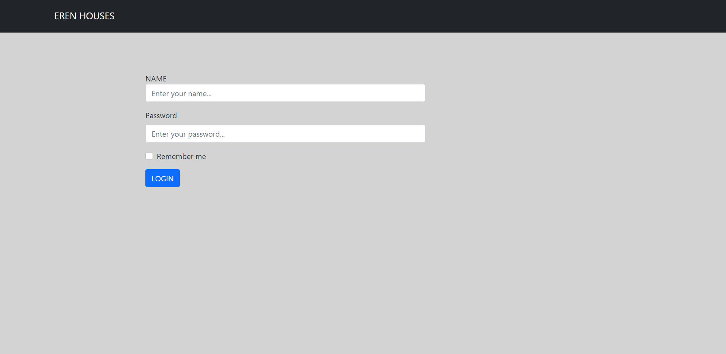

Hosts can enter the website after admin register. We choose remember our name and password if we want.

Homepage :

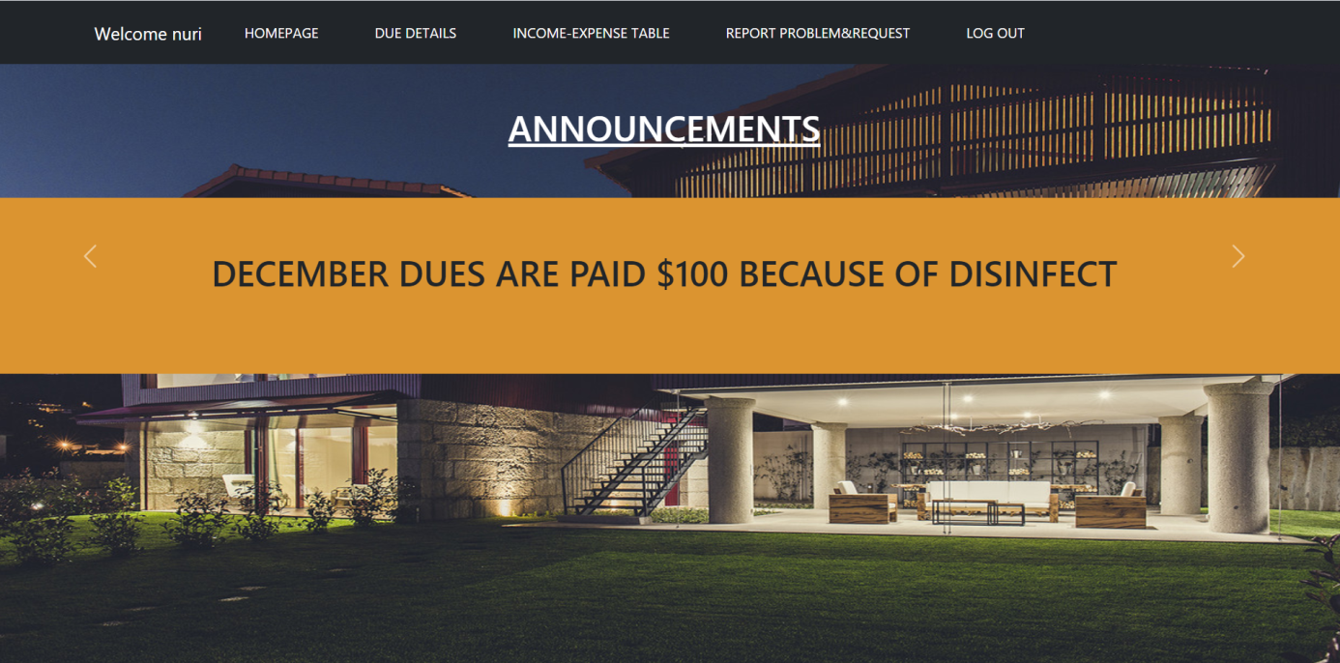

I used again bootstrap to make a navbar menu and slide bar. If we login as user, this page is waiting us. Hosts can check their due details, income-expense table, also they can report their problems or requests and then they can log out if they want.

Due Details :

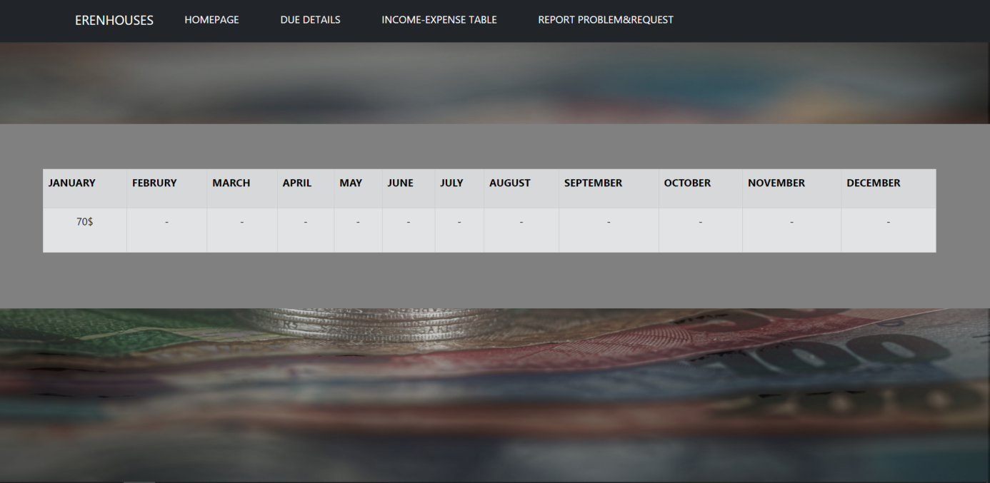

They can follow their dues status.

Income-Expense Table:

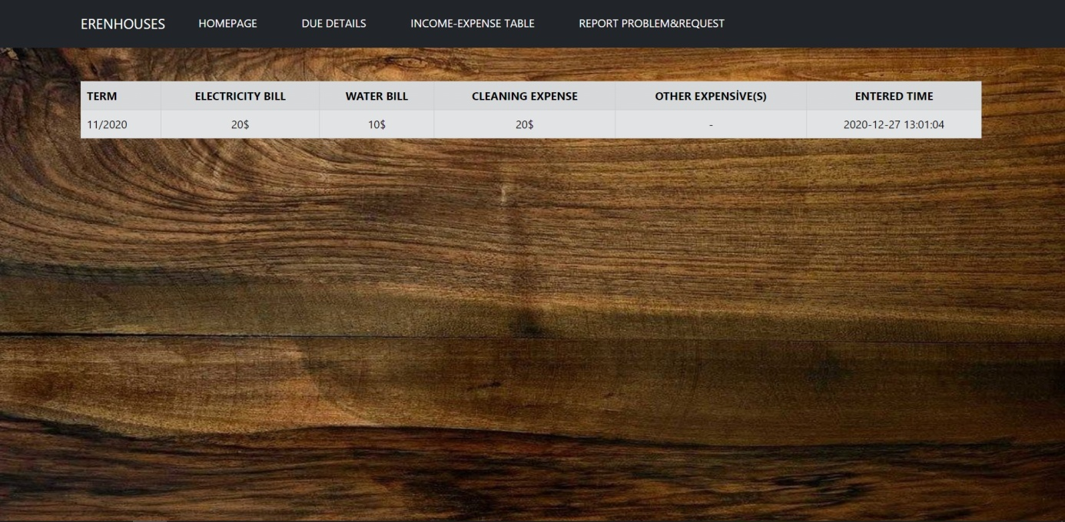

Hosts can see payment details for the site and see payment and announced time.

Report Problem OR Request:

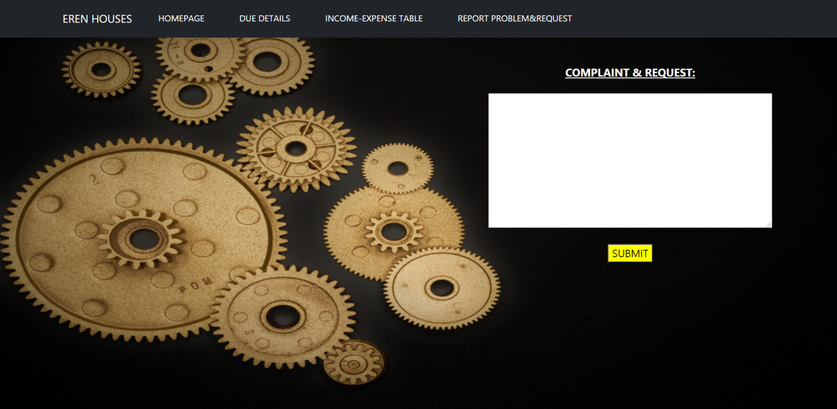

Hosts can notify their problems or requests.

ADMIN LOGIN :

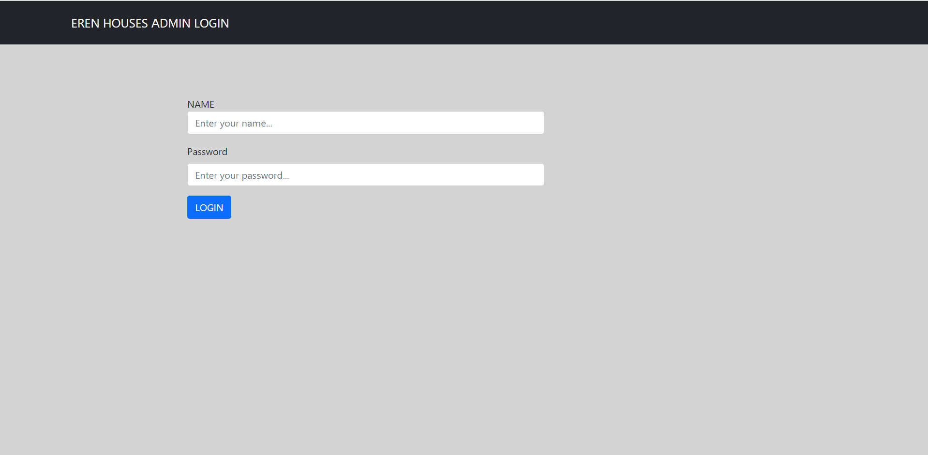

Admin or admins should enter their name and password to login admin panel.

Admin Panel :

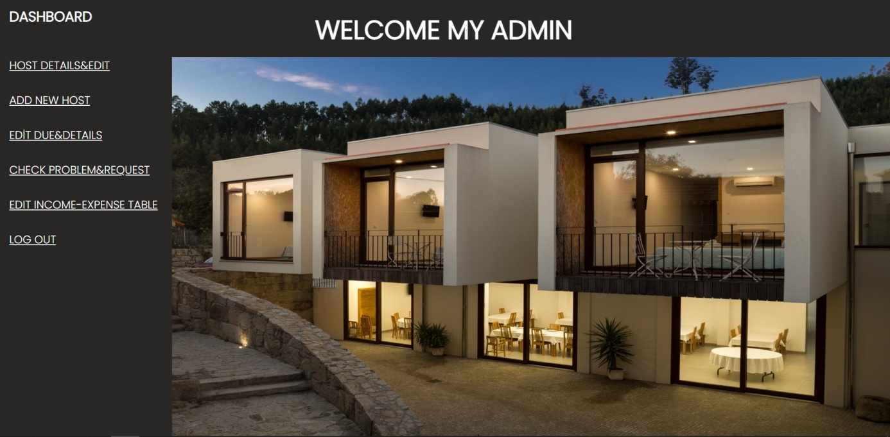

Welcome admin panel. Admin can check hosts informations and edit them, add a new host, see hosts’ due status and edit them, check hosts problems and requests. Admin(s) also can see income-expense table and add expenses for a month.

Host Details and Edit :

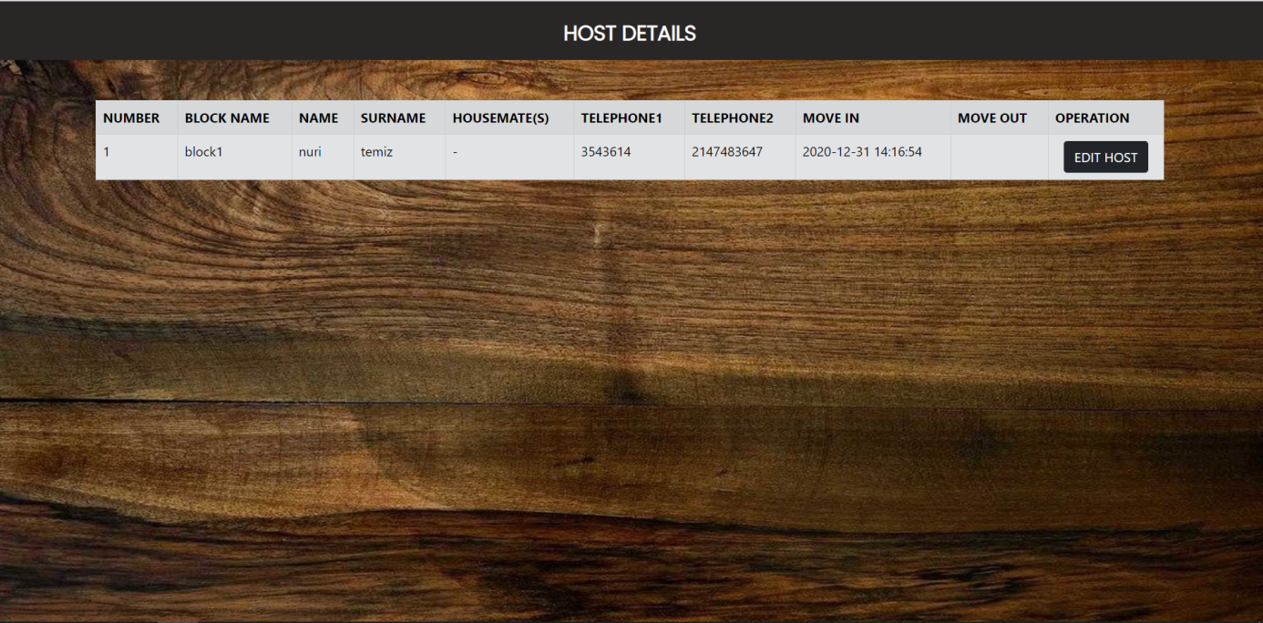

Host details page. Admin can edit their information also add move out date if they move out. However, this page shows us hosts that stil live in the ERENHOUSES.

Edit Host :

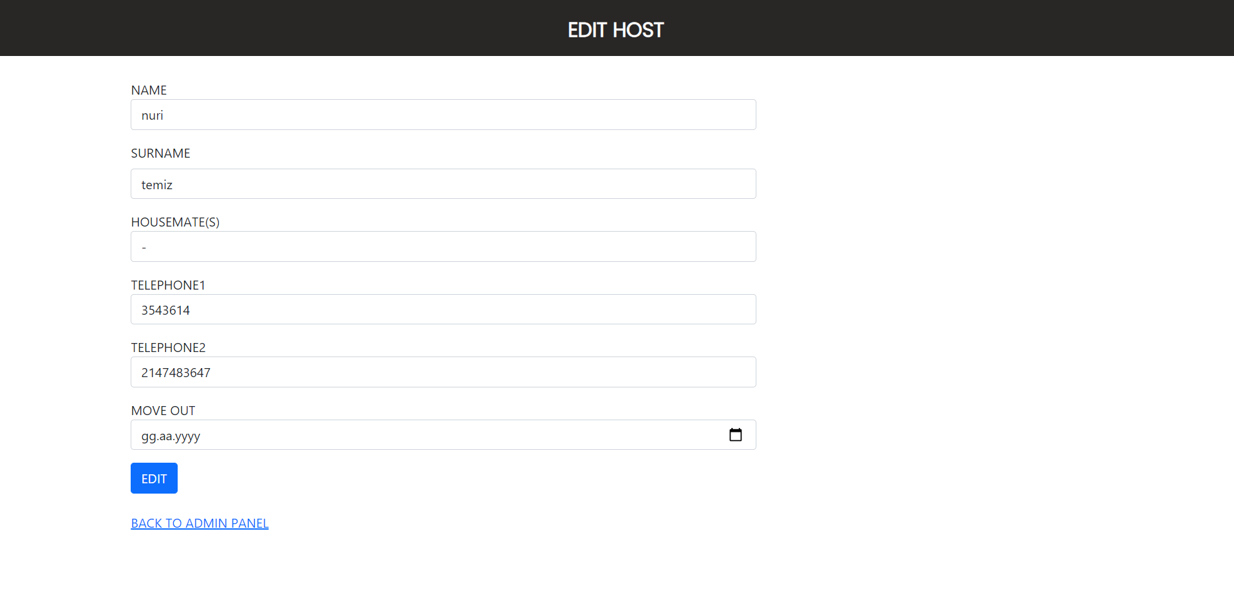

Admin can edit hots information and also add move out date if it moved.

Add New Host :

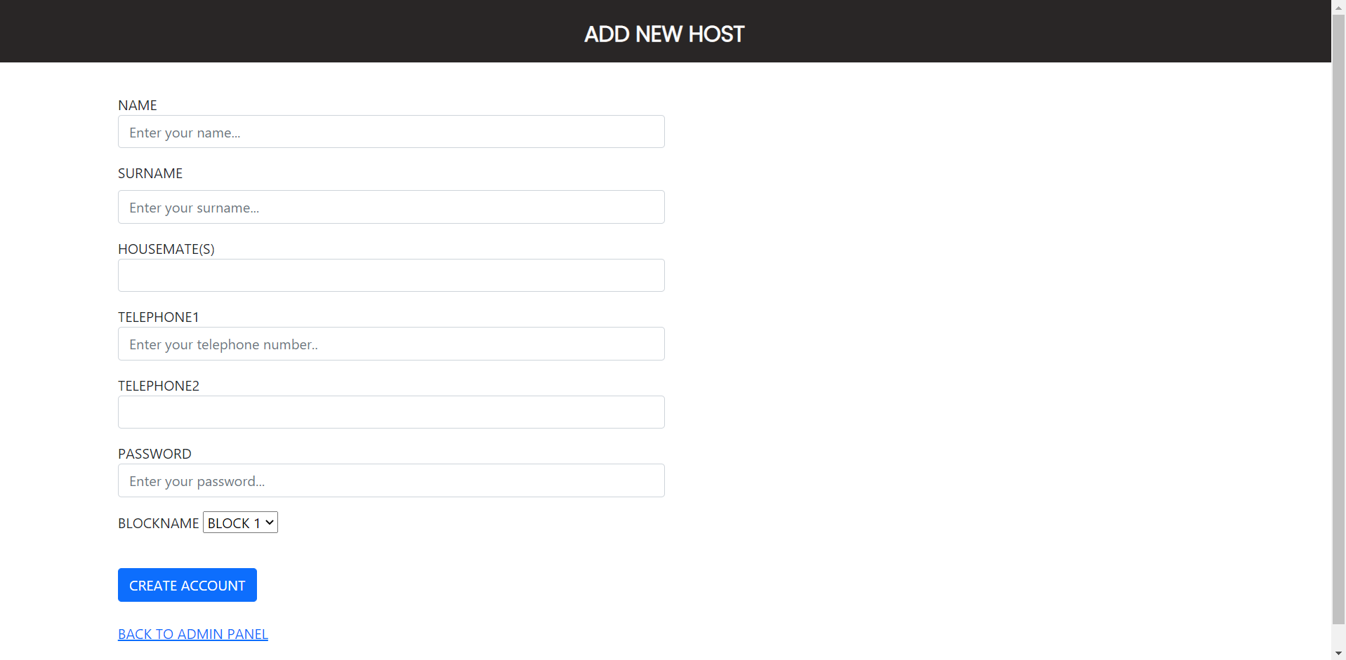

Admin can enter host that moved in the site. Host must fill in the form. Also blockname is unique.

Edit Due And Details :

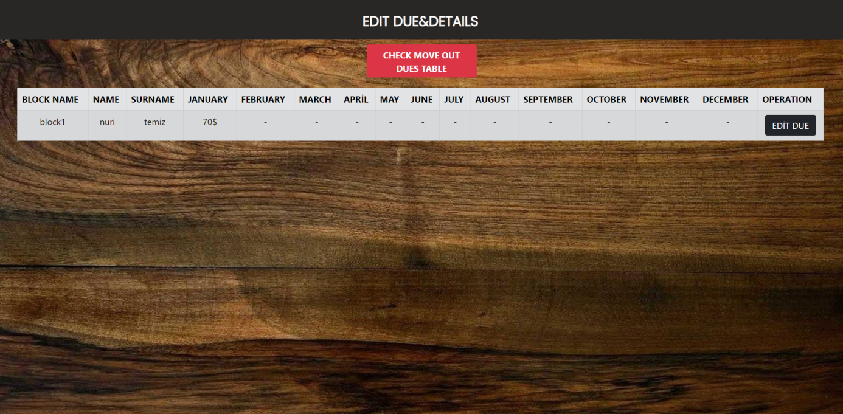

Admin(s) can check hosts’s due status and can change. Also can see old hosts status that move out from the site.

Edit Due Page :

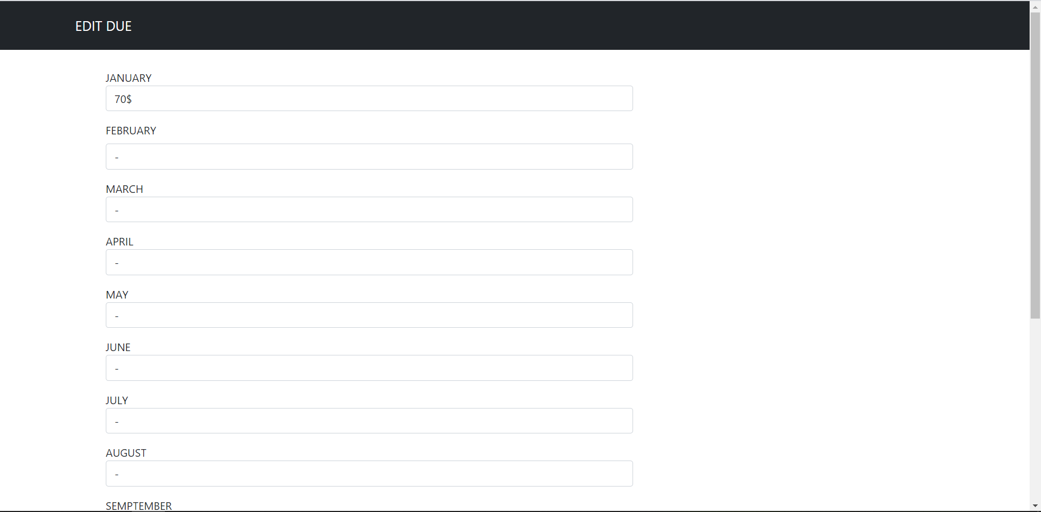 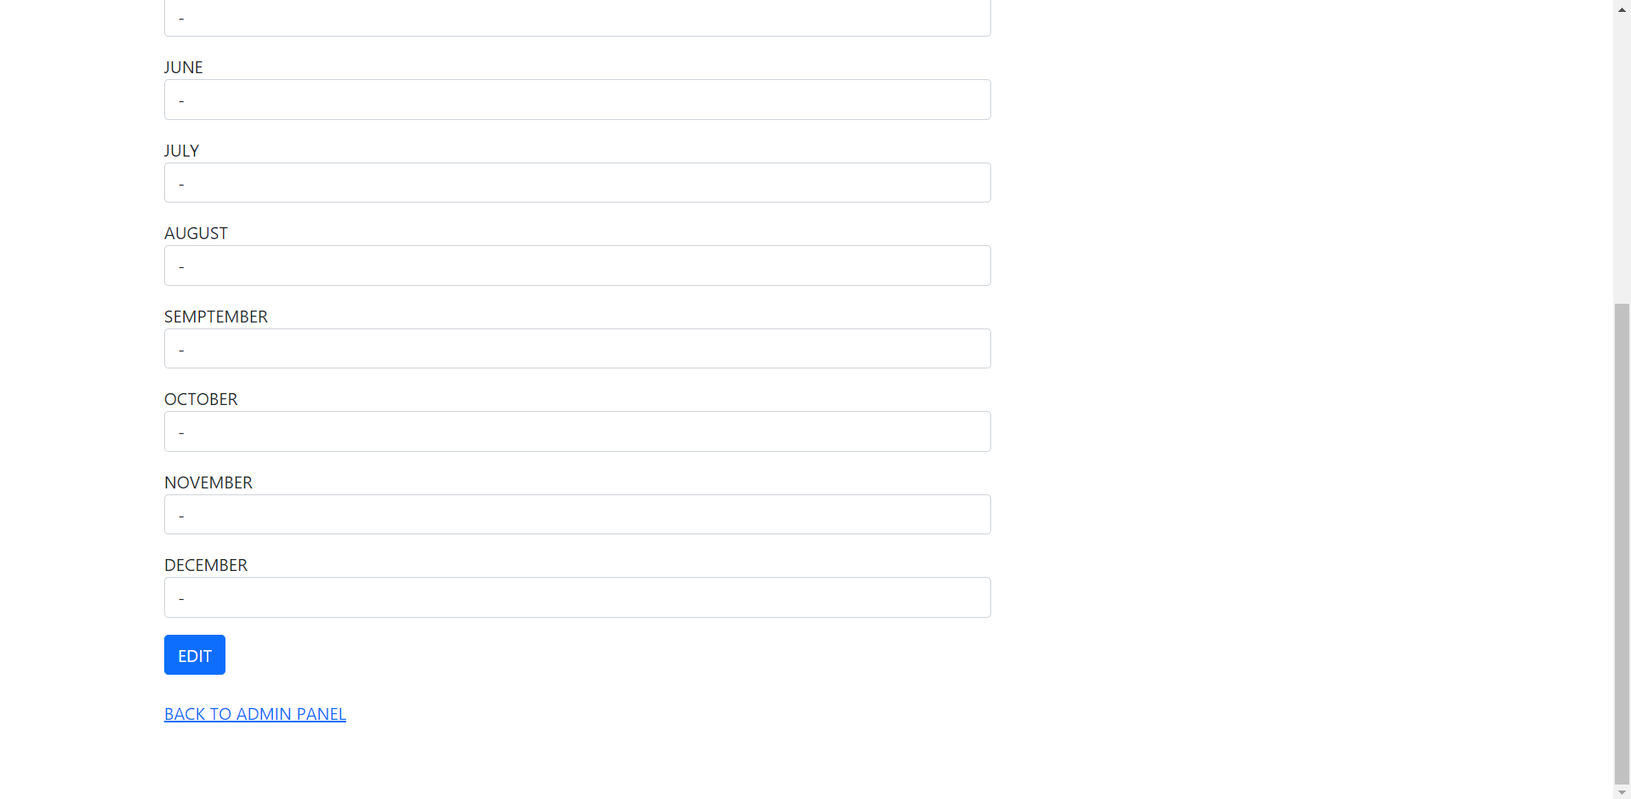

If any host paid own due(s), admin can edit information for the due table.

Check Move Out Dues Table :

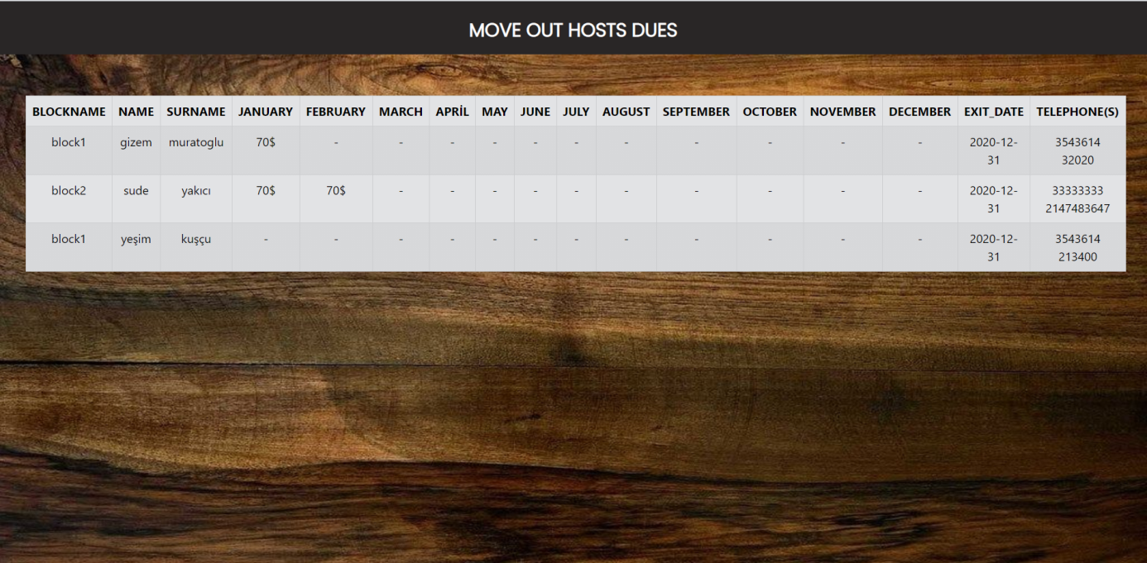

Admin(s) can see old hosts due status, date that moved out and also hosts contact information.

Check Problem And Request :

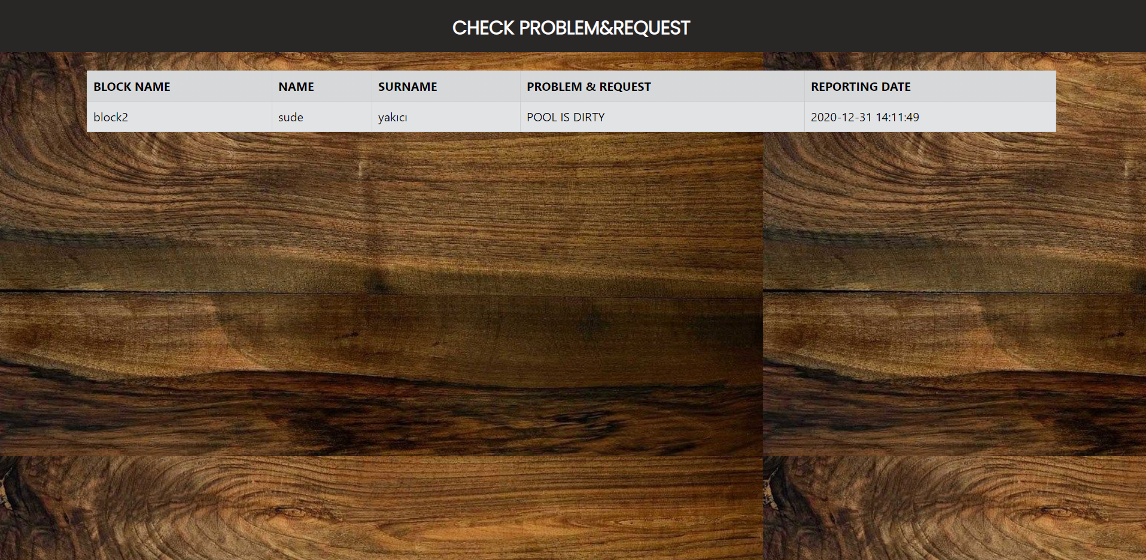

Admin(s) can see hosts problems and requests on this page.

Income-Expense Table :

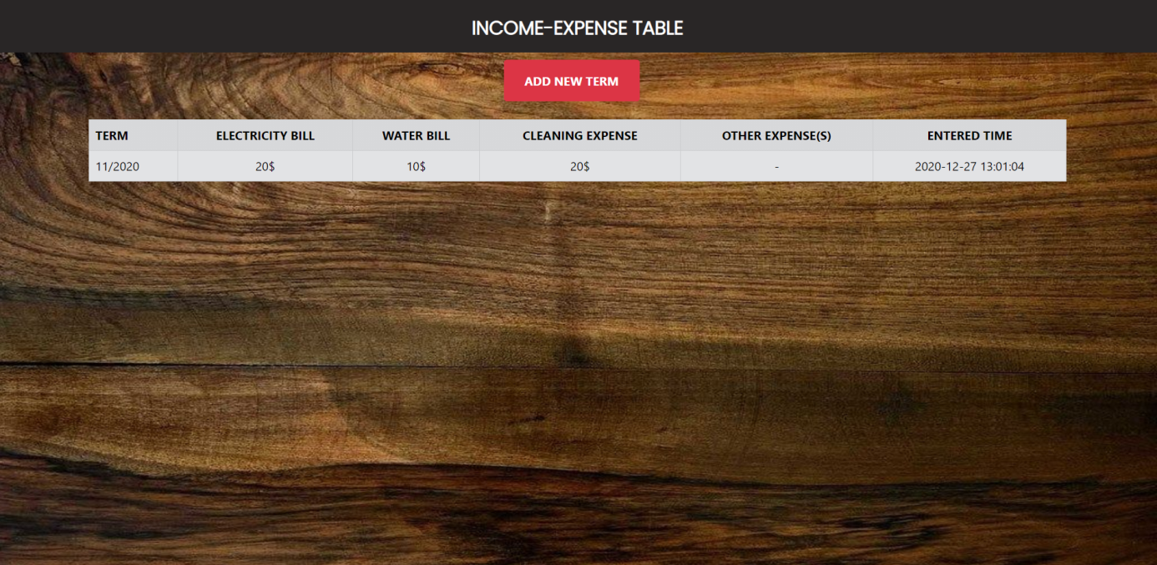

Admin(s) can enter bills and other expense(s) to notify hosts in the site.

Add New Term :

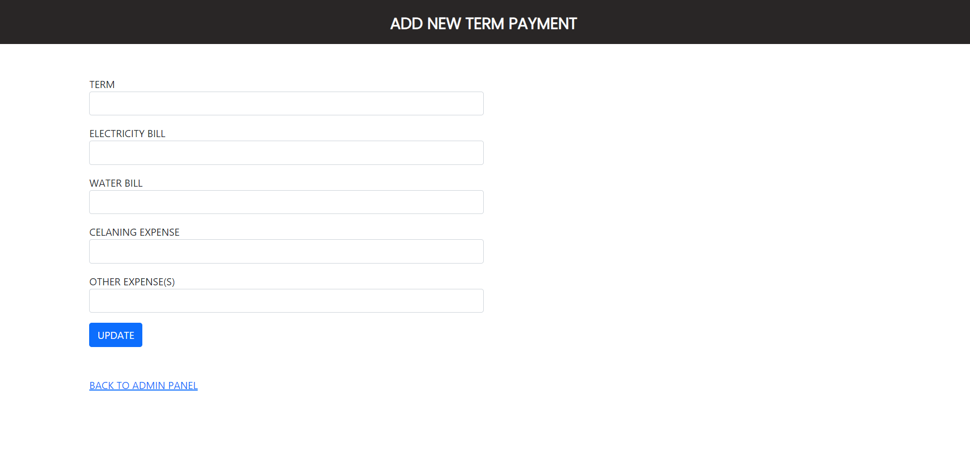

Term, bills, expenses are entered to notify hosts by admin(s).

I

lksdl